# Muslim Diversity Study: Quantitative protocol and practical insights on engaging New Zealand’s Muslim communities

M. Usman Afzali1,2, Jamila S. Badis2, Parus Khoso3, Farah Shawkat1, Fatima A. Junaid4, Ayca Arkilic5, Mazharuddin Syed Ahmed6, Hussain Raissi7, Hala Burhoum2, Tuba Azeem8, Iman Husain2, Zarqa Shaheen Ali9, Zahra Haidary2, Mashal Khan2, Mai Tamimi10, Nasratullah Hamid11, Gul e Aqsa12, Zahra Emamzadeh13, Rizwan Sulehry14, Somia Tasneem15, Aamina Ali16, Adepate Mustapha-Koiki17, Afrah Ali10, Sandila Tanveer11, Aarif Rasheed18, Kumar Yogeeswaran2, Chris G. Sibley19, and Joseph A. Bulbulia20,21

1Religion Programme, University of Otago

2School of Psychology, Speech and Hearing, University of Canterbury

3College of Education, University of Canterbury

4School of Management, Massey University

5School of History, Philosophy, Political Science and International Relations, Victoria University of Wellington

6Engineering and Architectural Studies, Ara Institute of Canterbury

7The National Centre for Peace and Conflict Studies, University of Otago

8Faculty of Law, Victoria University of Wellington

9ICL Business School, New Zealand Skills and Education College

10Independent Researcher

11Department of Psychological Medicine, University of Otago Christchurch

12School of Health Sciences, University of Canterbury

13School of Language, Social & Political Sciences, University of Canterbury

14School of Management, Victoria University of Wellington

15Department of History, Government College University, Faisalabad, Pakistan

16PsychologyNZ

17Department of Politics and International Relations, University of Auckland

18Just Community

19School of Psychology, University of Auckland

20School of Psychology, Victoria University of Wellington

21Department of Linguistic and Cultural Evolution, Max Planck Institute for Evolutionary Anthropology

# Author Note

M. Usman Afzali  http://orcid.org/0000-0001-5119-9388

Jamila S. Badis  http://orcid.org/0009-0005-2866-5033

Parus Khoso  http://orcid.org/0000-0001-6384-038X

Farah Shawkat  http://orcid.org/0009-0006-0319-9117

Fatima A. Junaid  http://orcid.org/0000-0002-6656-8120

Ayca Arkilic  http://orcid.org/0000-0002-1775-3311

Mazharuddin Syed Ahmed  http://orcid.org/0000-0000-0000-0001

Hussain Raissi  http://orcid.org/0009-0000-7985-1622

Hala Burhoum  http://orcid.org/0000-0000-0000-0001

Tuba Azeem  http://orcid.org/0000-0002-0611-8726

Iman Husain  http://orcid.org/0000-0003-4032-4387

Zarqa Shaheen Ali  http://orcid.org/0000-0002-7145-5788

Zahra Haidary  http://orcid.org/0009-0000-5259-622X

Mashal Khan  http://orcid.org/0009-0004-5903-3306

Mai Tamimi  http://orcid.org/0000-0000-0000-0000

Nasratullah Hamid  http://orcid.org/0009-0002-0120-7428

Gul e Aqsa  http://orcid.org/0009-0003-0928-8039

Zahra Emamzadeh  http://orcid.org/0009-0007-3065-2199

Rizwan Sulehry  http://orcid.org/0000-0002-1209-0635

Somia Tasneem  http://orcid.org/0000-0001-5471-6934

Aamina Ali  http://orcid.org/0009-0000-8153-8432

Adepate Mustapha-Koiki  http://orcid.org/0000-0003-4731-1781

Afrah Ali  http://orcid.org/0009-0004-5856-4025

Sandila Tanveer  http://orcid.org/0000-0002-0648-5382

Aarif Rasheed  http://orcid.org/0000-0000-0000-0001

Kumar Yogeeswaran  http://orcid.org/0000-0002-1978-5077

Chris G. Sibley  http://orcid.org/0000-0002-4064-8800

Joseph A. Bulbulia  http://orcid.org/0000-0002-5861-2056

The hypotheses and data analysis plan for this study were preregistered at OSF <https://doi.org/10.17605/OSF.IO/B39XT>. The data described in this study are part of the Muslim Diversity Study, which is conducted under the [New Zealand Attitudes and Values Study](https://osf.io/75snb/). The authors have no conflicts of interest to disclose. The Muslim Diversity Study - officially known as “A National Longitudinal Study of Muslim Diversity and Flourishing” is supported by a grant from the Templeton Religion Trust (TRT-2022-30579). The funders had no role in preparing the manuscript or the decision to publish it. The authors are grateful to W. Joel Schneider for the [Quarto template](https://github.com/wjschne/apaquarto).

Author roles were classified using the Contributor Role Taxonomy (CRediT; https://credit.niso.org/) as follows: *M. Usman Afzali***:** conceptualisation, data curation, formal analysis, funding acquisition, investigation, methodology, project administration, resources, supervision, visualisation, writing – original draft, and writing - review & editing. *Jamila S. Badis***:** data curation, project administration, writing – original draft, and writing - review & editing. *Parus Khoso***:** data curation, formal analysis, writing - original draft (pilot community consultation), and writing - review & editing. *Farah Shawkat***:** data curation, writing - original draft (method), and writing - review & editing. *Fatima A. Junaid***:** writing - original draft (introduction) and writing - review & editing. *Ayca Arkilic***:** writing - original draft (introduction) and writing - review & editing. *Mazharuddin Syed Ahmed***:** data curation and writing - review & editing. *Hussain Raissi***:** data curation, writing - original draft (method), and writing - review & editing. *Hala Burhoum***:** data curation, writing - original draft (method), and writing - review & editing. *Tuba Azeem***:** data curation and writing - review & editing. *Iman Husain***:** data curation, writing - original draft (method), and writing - review & editing. *Zarqa Shaheen Ali***:** data curation, writing - original draft (method), and writing - review & editing. *Zahra Haidary***:** data curation, writing - original draft (method), and writing - review & editing. *Mashal Khan***:** data curation, writing - original draft (method), and writing - review & editing. *Mai Tamimi***:** writing - original draft (method) and writing - review & editing. *Nasratullah Hamid***:** data curation, writing - original draft (method), and writing - review & editing. *Gul e Aqsa***:** data curation and writing - review & editing. *Zahra Emamzadeh***:** writing - original draft (strengths & limitations) and writing - review & editing. *Rizwan Sulehry***:** data curation, writing - original draft (strengths & limitations), and writing - review & editing. *Somia Tasneem***:** writing - original draft (strengths & limitations) and writing - review & editing. *Aamina Ali***:** writing - original draft (applications & implications) and writing - review & editing. *Adepate Mustapha-Koiki***:** writing - original draft (applications & implications) and writing - review & editing. *Afrah Ali***:** writing - review & editing. *Sandila Tanveer***:** writing - review & editing. *Aarif Rasheed***:** conceptualisation, data curation, funding acquisition, resources, and writing - review & editing. *Kumar Yogeeswaran***:** conceptualisation, funding acquisition, methodology, writing – original draft, and writing - review & editing. *Chris G. Sibley***:** conceptualisation, data curation, funding acquisition, methodology, project administration, resources, supervision, writing - review & editing, and development and management of the New Zealand Attitudes and Values Study panel data collection from 2009 to the present. *Joseph A. Bulbulia***:** conceptualisation, funding acquisition, methodology, project administration, resources, supervision, writing – original draft, and writing - review & editing

Correspondence concerning this article should be addressed to M. Usman Afzali, Religion Programme, University of Otago, 362 Leith Street, Dunedin, Otago 9016, New Zealand, Email: usman.afzali@otago.ac.nz

# Abstract

The New Zealand Attitudes and Values Study (NZAVS) represents a substantial longitudinal research initiative aimed at comprehensively understanding the social values and attitudes prevalent among New Zealanders. The NZAVS is distinguished by its extensive examination of various social, political, and health-related dimensions of life in New Zealand, with a particular emphasis on investigating negative attitudes towards minority groups, including manifestations of discrimination and prejudice. In response to 2019 Christchurch attacks, our objective was to utilize data from the NZAVS to gain insights into Islamophobia and its repercussions for the Muslim community. Furthermore, we sought to explore the overall wellbeing and flourishing of Muslims in New Zealand, investigating how values, identity, religiosity, and meaning-making influence Muslims’ self-perception and health outcomes. However, the limited sample size of Muslims within the NZAVS posed a challenge to making robust inferences. To address this limitation, the current project was conceived to recruit a larger cohort of Muslim participants within the NZAVS framework over a three-year quantitative longitudinal study. This article has two major parts. Firstly, it delineates the contextual motivations for this research, the pilot consultation with the Muslim community, and the decisions made and adjusted based on this consultation. It also outlines the data collection methods, research team functions, quantitative measures used, and timeline. Secondly, it provides practical guidelines in terms of data collection drawing on our understanding of enablers and challengers of data collection from a culturally distinct religious community in New Zealand. Hence, this article will serve as a reference text for researchers conducting work not only on Muslims in New Zealand but also on other ethnic and religious communities and minorities in the country. It will also allow researchers to apply the methods to other contexts and regions across the world to provide comparative insights and analyses.

*Keywords*: Muslims, diversity, New Zealand, Muslim Diversity Study (MDS), New Zealand Attitudes and Values Study (MDS)

# Muslim Diversity Study: Quantitative protocol and practical insights on engaging New Zealand’s Muslim communities

On 15 March 2019, a devastating far-right extremist attack on two mosques took place in Christchurch, killing 51 Muslims and injuring 40 (*Royal Commission of Inquiry into the Terrorist Attack on Christchurch Masjidain on 15 March 2019*, 2020). Although this attack was widely condemned (*World Leaders Condemn New Zealand Mosque Attacks*, 2019) and was unprecedented in New Zealand (*Jacinda Ardern on the Christchurch Shooting*, 2019), it was not as surprising to the Muslim community (A. Rahman, 2019) due to Muslims’ widespread experience of Islamophobia and prejudice in the country (Sibley et al., 2020). Even as Islamophobia has reportedly increased overseas following these attacks (*Islamophobia After Christchurch Terror Attacks Quadrupled - Australian Report*, 2022), the evidence in New Zealand seems to be mixed. While news articles have reported increased hate towards Muslims (Frykberg, 2023), the New Zealand Attitudes and Values Study (NZAVS) findings were indicative of improved attitudes towards Muslims (Bulbulia et al., 2023; Shanaah et al., 2021) following the attacks. Addressing this discrepancy is beyond the scope of the current article; however, it is worth noting that most of our research in this area, primarily through the NZAVS (Sibley, 2024) lens, has so far shed light on such attitudes from a non-Muslim perspective. In other words, we have mostly reported on how Muslims are perceived by non-Muslim members of New Zealand society, rather than how Muslims perceive themselves. While the published NZAVS reports are an absolute necessity, the self-experience of Muslims themselves as the direct victims of this heinous crime is equally important.

The current article has two major goals. Firstly, it elaborates on the protocol of pioneering a three-year longitudinal study titled the Muslim Diversity Study (MDS) poised to achieve this very goal – examining Muslims’ self-perception in New Zealand from a variety of angles, as well as, the predictors of resilience, flourishing, and wellbeing within Muslims. The study started in 2023 and is planned to conclude in 2026. The goal is to achieve as many as 650 Muslim respondents.

Secondly, MDS was co-designed with the members of the New Zealand Muslim community. This consultation continued during the first year of data collection. We are aiming to lay out the context of MDS by explicitly explaining the processes before and during the project and how we used community and MDS team feedback to enhance data collection. We believe this article would provide a comprehensive guideline for working with the Muslim community in Western countries.

## Introduction

The Muslim community has been expanding in New Zealand. Based on the 2018 census, New Zealand has more than 60,000 Muslims which has grown to over 75,000 according to the 2023 Census (*Stats NZ*, 2024). Studies also show that the number of converts to Islam has increased after the 2019 terror attack (Arkilic, 2020). The Muslim community is uniquely positioned in New Zealand: a growing religious minority and a historically stigmatised group that was the direct target of the 2019 terrorist attack (*Royal Commission of Inquiry into the Terrorist Attack on Christchurch Masjidain on 15 March 2019*, 2020; Sibley et al., 2020).

Muslim Diversity Study (MDS) — officially known as *A national longitudinal study of Muslim diversity and flourishing* — embraces a community-oriented approach by collaborating with the Muslim community in order to make decisions about the execution of data collection and for identifying key questions of interest for the community at large. It is important that such processes and decisions are recorded in the form of a study protocol so that our findings are shared with the broader public and future researchers in New Zealand and across the globe can benefit from our outputs.

The protocol addresses MDS’ pilot community consultation, the decisions made and modified based on the consultation, community engagement, data collection, the teams involved, measures used, and proposed data analysis plan. Learning from this, a comprehensive guideline is presented addressing enablers and challenges of data collection from Muslims. To set the rationale for MDS, it is important to briefly overview the attitudes towards Muslims in New Zealand.

## The need for Muslim Diversity Study

Muslims have generally faced prejudicial attitudes in New Zealand (Greaves et al., 2020; Sibley et al., 2020; Yogeeswaran et al., 2019). Until the Christchurch terror attack, news stories on Islam and Muslims in New Zealand media were mostly an extension of ‘the negative othering rhetoric’, and the national media tended to link Muslim converts to jihadis (Drury, 2016). Unsurprisingly, such rhetoric has been found to foster anti-Muslim prejudice (Shaver et al., 2017).

In the aftermath of Christchurch shootings, the New Zealand government introduced unprecedented counter-terrorism measures such as the prohibition of the sale of all military-style semi-automatic and assault rifles and creating the Royal Commission of Inquiry into these attacks (*Royal Commission of Inquiry into the Terrorist Attack on Christchurch Masjidain on 15 March 2019*, 2020). The Royal Commission of Inquiry presented an 800-page report emphasising New Zealand’s inclusive and welcoming identity, among other measures (Arkilic, 2021). In addition, the New Zealand press embraced a more inclusive and positive narrative with respect to Islam and Muslims (Kabir, 2024; K. A. Rahman, 2020).

Although there have been sporadic reports of increased hate crimes after the attacks (Wilson & Shastri, 2020), the average sentiments towards Muslims have improved in New Zealand. The New Zealand Attitudes and Values Study (NZAVS), in a series of articles, reported this positive shift in these attitudes toward Muslims post Christchurch attacks (Bulbulia et al., 2023; Shanaah et al., 2021), and the psychological response of New Zealand public to the shootings (Byrne et al., 2022).

The Christchurch shootings prompted many New Zealand research groups and institutions to further study about Muslims and with Muslims, who so far had been a culturally-distinct, under-researched, minority group. These studies included trauma-focused response (Sulaiman-Hill et al., 2021; Sulaiman-Hill et al., 2024), inclusion, Islamophobia and wellbeing (Junaid et al., 2024), perceived discrimination among Muslim immigrant youth (Raissi, 2024), the political implications of government decisions (Arkilic, 2021) among others. Given that at NZAVS we had explored perceptions of Muslims and the mechanisms of attitudinal changes towards Muslims following 15 March 2019 attacks (Bulbulia et al., 2023; Hawi et al., 2019; Shaver et al., 2017; Sibley et al., 2020), it was a timely necessity that we expanded our reach further.

The NZAVS is a planned 20-year-long longitudinal national probability annual panel study of social attitudes, personality, ideology and health outcomes that began in 2009 and is currently in its 15th year. It has so far collected data from more than 70,000 New Zealand residents using the electoral roll (Sibley, 2024). The NZAVS has been instrumental in exploring key issues related to minorities, including but not limited to discrimination, intergroup relations, identity, distress, security, and the dynamics and mechanisms behind them.

The NZAVS has been uniquely positioned due to its prestigious reputation (over 150 peer-reviewed publications), longitudinal panel design, large sample size, and a large multi-disciplinary research team (Sibley, 2024). More importantly, NZAVS has a nationally representative sample with data from different identity and religious group (Sibley, 2024), thereby allowing us to compare data from different identity groups. However, the Muslim sample in NZAVS had been less than 100 (Sibley, 2024), which did not allow us to make meaningful inferences regarding Muslim lives and issues in comparison with other religious groups. Hence, it was justified to collect more data from Muslims in New Zealand.

In addition, much of the NZAVS work to date with the Muslim community had focused on conveying information about how Muslims are perceived by the non-Muslim members of New Zealand society. After receiving strong positive suggestions from the Muslim community to scientifically explore diversity, discrimination, self-perception, resilience, meaning-making and flourishing, this three-year longitudinal study was conceived in 2022 to address this scholarly and community knowledge gap. Therefore, MDS is effectively a booster to NZAVS, and uses the NZAVS questionnaires to collect data from the members of Muslim community in New Zealand.

We aim to explore the diversity of Muslims in New Zealand, assess Muslims’ perceived discrimination in comparison with other religious groups, unearth predictors of their flourishing and meaning-making, and measure the effect of service-attendance and religious-identification on these constructs.

The co-design of MDS with Muslim community initiated with community consultation as detailed below.

## Co-designing MDS: Community consultation

Prior to applying for the research grant, we deemed it necessary to consult with the Muslim community to gauge interest in the project, and the feasibility of the project for the community. More importantly, inferring from the culturally-focused research groups, it was important to co-design the project with Muslims by consulting with the academics and leaders of the Muslim community. Therefore, we started engaging with the Muslim community in February, 2022 — one year before the start of the project — to co-design the project.

This consultation continued until November, 2022 where the principal investigator (MUA) reached out to 29 Muslims in six cities, Auckland, Hamilton, Palmerston North, Wellington, Christchurch, and Dunedin, from various age groups, genders, and cultural backgrounds. Twenty of these conversations took place with community leaders, religious scholars, academics, and cultural organisation leaders, while 9 conversation took place with individual activists. The conversations were focused around four objectives: 1) To assess the feasibility of the project for Muslims, 2) To assess the interest of Muslims in the project, 3) To get feedback on the survey items, design, and working with the community, and 4) To inquire if translation of the questionnaire may be needed. The consultation revealed unanimous agreement among respondents regarding the study’s feasibility and timeliness for the Muslim community, with expectations of strong interest in participation. The respondents indicated that the highest engagement would likely come from youth groups, subsequent-generation migrants, those with formal education, and female participants. Furthermore, the respondents not only endorsed the significance of the study and its planned measures but also pledged their comprehensive support for the initiative.

A few challenges were also identified with regards to the execution of the study: 1) The participation from Christchurch might not be up to the anticipated levels as after the Christchurch shooting, people were frequently surveyed and not provided with the findings, which might affect their interest to participate in the study. 2) It might not be easy for all prospective participants to understand the questionnaires due to the community’s unfamiliarity with research and limitations with fluency in English. 3) The participation from the elderly community (due to unfamiliarity with research) and Muslim converts (due to distrust of the institutions) might also be low. 4) Community members might be suspicious and consider the study to have ulterior or personal motives. Similar challenges have been identified by other researchers who have worked with the Muslim community in New Zealand (Sulaiman-Hill et al., 2024).

The following recommendations on mitigating these challenges were received upon completing the consultation: 1) To encourage more participation from the Muslim community, findings should be shared with the wider community in future owing to the diversity it will present. To be able to share the research findings with the community smoothly and keep them up-to-date, it was recommended to have a dedicated website for the study. Therefore, instead of calling it a booster to NZAVS, the project was named Muslim Diversity Study, and a website of the same name was created. 2) Although many said that the questionnaire needs to be translated into seven ethnic languages in connection to reducing the difficulty in reaching the diverse members of the community for the study, they also indicated that a majority of the potential participants could comprehend the English version easily. 3) It was proposed that we should reach out to the community via trusted community leaders/members, ethnic and religious organisations, and mosques, and that for youth engagement, we should go via youth organisations such as Muslim Student Associations (MSAs) at universities. A family-focused strategy was advised to be beneficial as starting with the men was implied to be more effective. 4) To assuage the possible distrust around the motives of the study, the participants must be clearly informed about the study’s rationale and its benefits to the community, reiterating that it will increase Muslims’ visibility and raise their voice in research. The long-term value of the study for the community as a whole as well as their children should also be emphasised.

This process led to developing a comprehensive guideline that addresses feasibility, advice on engagement with the community, the possible challenges, and avenues to enhance participation. The 29 participants of this pilot consultation form the Advisory Group of MDS and are being regularly consulted.

## Translation

Our consultation with the community revealed that the need for translation of the questionnaire may be limited to a small subset of New Zealand Muslims, as the majority are expected to be proficient in English. This finding aligns with the research conducted by the March 15 Project team (Sulaiman-Hill et al., 2021). Their study found that 71% of participants preferred English for surveys and clinical interviews (Sulaiman-Hill et al., 2024).

A critical component of the Muslim Diversity Study (MDS) is the comparison of Muslim scores on the New Zealand Attitudes and Values Study (NZAVS) with those of other religious groups. The introduction of a translated questionnaire poses the risk of not capturing attitudes and behaviors with the same accuracy as the English version. Consequently, any observed differences in scores between Muslims and other groups could be attributed to translation bias rather than genuine differences in religious affiliation.

This concern was presented to the Advisory Group, which recommended against translating the questionnaire. Instead, it was advised to provide the English version to all potential Muslim participants. This approach offers a methodological safeguard, ensuring that the conceptual meanings are preserved and not distorted by translation. By maintaining the integrity of the questionnaire, we can be more confident in the validity of the comparative analyses between religious groups.

## Item retention and religious Context Considerations

The consultation process with the MDS Advisory Group identified six items in the New NZAVS questionnaire that could potentially appear irrelevant to Muslim participants, given the questionnaire’s original development within a predominantly Christian context. Despite these potential concerns, a substantial majority of the Advisory Group (81% average across all six items) recommended retaining these items to enable meaningful cross-religious comparisons in the analysis.

To address potential participant concerns about item relevance, we included in the survey instructions: “As the survey is designed for the general New Zealand population, there may be questions that do not necessarily apply to you. Please feel free to skip any questions that you do not wish to answer.” This approach maintains methodological consistency while acknowledging and accommodating the diverse religious perspectives of participants.

## Study aims

This study aims to investigate the role of religious community engagement in buffering Muslims against anti-Muslim prejudice, to examine the employment and health challenges faced by Muslims relative to other religious groups, and to explore the similarities in subjective wellbeing and psychological distress across religious affiliations, emphasizing the protective effects of community support and religious community-making. This comprehensive approach enables the examination of both direct relationships and complex mediating pathways between religious community engagement, experienced prejudice, employment and health outcomes, and psychological wellbeing. Through this multi-faceted investigation, the study seeks to contribute to our understanding of the Muslim experience in New Zealand and the role of religious community support in promoting positive outcomes across various life domains.

# Method

## Sample size estimation and participants

The NZAVS sample of Muslim cohort was less than 100 (Sibley, 2024). To enhance the representation of Muslims in NZAVS, we aim to recruit an additional 650 participants, aligning with the study’s proportional sampling methodology for the general population. This target corresponds to about 1.3% of New Zealand’s Muslim population based on the 2018 Census (*Stats NZ*, 2024). Notably, the 2023 Census that took place after the the starts of MDS shows an increased number of Muslims in New Zealand (75,138) (*2023 Census Population, Dwelling, and Housing Highlights*, 2024). Data collection was concentrated in six major urban centers—Auckland, Christchurch, Hamilton, Wellington, Palmerston North, and Dunedin—each with a Muslim population of at least 1,000 (see Table 1). Participants were eligible if they self-identify as Muslim, were 18 years or older, and currently resided in New Zealand. There were no exclusion criteria. By conclusion of Wave 15, the sample size of NZAVS is 32,857, with further details available online (<https://osf.io/75snb/>). The number of Muslims who joined the NZAVS is a result of MDS is 582, and as a result, the total number of Muslim participants in NZAVS Wave 15 is 667.

## Materials

In this protocol, we are highlighting measures that are pertinent to the planned papers aimed at communicating the findings emerging from MDS. The complete list of NZAVS measures can be accessed online (<https://osf.io/75snb/>).

For Likert type scales, the minimum and maximum levels are noted along with the description: for instance, 1 = Not Important, 7 = Very Important would mean that a score ranges between 1 and 7, with 1 being the minimum and 7 being the maximum score, whereas (R) indicates the reverse-scored items. Notwithstanding, we might choose to explore further measures which will then be elaborated on in the individual articles.

### Service attendance and religiosity

1. Do you identify with a religion and/or spiritual group? (Yes/No). If yes, what religion or spiritual group? (String entry).
2. How many times did you attend a church or place of worship in the last month? (String entry).
3. How many times did you pray in the last week? (String entry).
4. How many times did you read religious scripture in the last week? (String entry).
5. How important is your religion to how you see yourself? (1 = Not Important, 7 = Very Important).
6. I identify as a spiritual person. (1 = Strongly Disagree, 7 = Strongly Agree).
7. Do you believe in God? (Yes/No).
8. Do you believe in any form of spirit or life force? (Yes/No).

### Prejudice

1. I feel that I am often discriminated against because of my religious/spiritual beliefs. (1 = Strongly Disagree, 7 = Strongly Agree).
2. People from my ethnic group are discriminated against in New Zealand. (1 = Strongly Disagree, 7 = Strongly Agree).
3. I feel that I am often discriminated against because of my age. (1 = Strongly Disagree, 7 = Strongly Agree).
4. I feel that I am often discriminated against because of my ethnicity. (1 = Very Inaccurate, 7 = Very Accurate).
5. I feel that I am often discriminated against because of my gender. (1 = Very Inaccurate, 7 = Very Accurate).
6. Intergroup Warmth Ratings: Participants are asked to rate their feelings of warmth toward different groups using the “Feeling Thermometer Scale” for each group from least to most warmth on a 7-point scale where 1 = Least Warm and 7 = Most Warm (see Figure 1 for reference). Groups include NZ Europeans, Māori, Asians in general, Pacific Islanders, Elderly people, People with a disability, Refugees, Overweight people, Immigrants in general, Chinese, Indians, Muslims, LGBTQ+ people, People with mental illness.

### Felt belonging

1. I know that people in my life accept and value me. (1 = Very Inaccurate, 7 = Very Accurate).
2. I feel like an outsider. (1 = Very Inaccurate, 7 = Very Accurate).
3. I know that people in around me share my attitudes and beliefs. (1 = Very Inaccurate, 7 = Very Accurate).

### Support

1. There are people I can depend on to help me if I really need it. (1 = Strongly Disagree, 7 = Strongly Agree).
2. There is no one I can turn to for guidance in times of stress (R). (1 = Strongly Disagree, 7 = Strongly Agree).
3. I know there are people I can turn to when I need help. (1 = Strongly Disagree, 7 = Strongly Agree).

### Employment

1. What is your highest level of qualification? (String entry).
2. Are you currently employed (This includes self-employed or casual work)? (Yes/No). This leads to a four-point nominal response: employed full-time, employed part-time, unemployed, and not in the labour force.
3. In that job, what is your current occupation? (String entry).
4. What is the main activity of the business or employer that you work for? (String entry).
5. How long have you worked at your current organization? (String entry: years/months).
6. How satisfied are you with your current job? (1 = Not Satisfied, 7 = Very Satisfied).
7. How secure do you feel in your current job? (1 = Not Secure, 7 = Very Secure).
8. How valued do you feel by your current organization? (1 = Not valued, 7 = Very Valued).

### Health

1. In general, would you say your health is… (1 = Poor, 7 = Excellent).
2. I seem to get sick a little easier than other people. (1 = Strongly Disagree, 7 = Strongly Agree).
3. I expect my health to get worse. (1 = Strongly Disagree, 7 = Strongly Agree).
4. Do you have a health condition or disability that limits you, and that has lasted for 6+ months? (Yes/No). If yes, please state: (String entry).
5. How often do you have a drink containing alcohol? This is measured using a 6 point nominal scale (a. Never - I don’t drink, b. Monthly or less, c. Up to 4 times a month, d. Up to 3 times a week, e. 4 or more times a week, f. Don’t know).
6. Have you ever regularly smoked tobacco cigarettes? (Yes/No).
7. Have you ever regularly used e-cigarettes? (Yes/No).
8. Do you currently smoke tobacco cigarettes? (Yes/No).
9. Do you currently vape or use e-cigarettes? (Yes/No).
10. Access to and satisfaction with GP: Do you have a regular family doctor/GP? (Yes/No). (If yes) How satisfied are you with the service and care you receive from your family doctor/GP? (1 = Not Satisfied, 7 = Very Satisfied). Do you think your doctor/GP shares a similar cultural background to you? (1 = Definitely No, 7 = Definitely Yes). Does your doctor/GP respect your cultural background when you are discussing health issues with them? (1= Definitely No, 7 = Definitely Yes).
11. Please estimate how many hours you spent during each of the following things last week (String entry). Options provided: Working in paid employment, housework/cooking, looking after children, volunteer/charitable work, exercising/physical activity, watching TV/Netflix/movies, travelling/commuting, watching/reading news, using the internet (in total), using social media (e.g., Facebook), playing video games/computer games.
12. BMI: Calculated by using a person’s weight (kg) divided by square root of height (m) that is asked separately, using “What is your height? (String entry (metres))”, and “What is your weight? (String entry (kgs))”.
13. During the past month, on average, how many hours of actual sleep did you get per night? (String entry).
14. Do you have a health condition or disability that limits you, and that has lasted for 6+ months? (Yes/No). If yes, please state: (String entry).
15. Chronic diseases diagnosis: See Figure 2.

### Subjective wellbeing/psychological distress

Measured using the Kessler-6 items (items 1-6 in Figure 3) rated on a 5-point scale (0 = None of the time, 4 = All of the time) (Kessler et al., 2010).

### Meaning of life

Items are: “My life has a clear sense of purpose” (1 = Strongly Disagree, 7 = Strongly Agree) and “I have a good sense of what makes my life meaningful” (1 = Strongly Disagree, 7 = Strongly Agree).

### Life satisfaction and national wellbeing

Items from Figure 4 measured on 11-item measure (0 = Completely Dissatisfied, 10 = Completely Satisfied). In addition, “I am satisfied with my life (1= Strongly Disagree, 7 = Strongly Agree)” and “In most ways my life is close to ideal (1 = Strongly Disagree, 7 = Strongly Agree)” are used.

### Self esteem

Items are, “On the whole I am satisfied with myself”(1 = Very Inaccurate, 7 = Very Accurate), “I take a positive attitude toward myself” (1 = Very Inaccurate, 7 = Very Accurate) and “I am inclined to feel that I am a failure” (R) (1 = Very Inaccurate, 7 = Very Accurate).

### Gratitude

Items are, “I have much in my life to be thankful for” (1 = Strongly Disagree, 7 = Strongly Agree), “When I look at the world, I don’t see much to be grateful for” (1 = Strongly Disagree, 7 = Strongly Agree) and “I am grateful to a wide variety of people” (1 = Strongly Disagree, 7 = Strongly Agree).

### Community making

I feel a sense of community with others in my local neighbourhood (1 = Strongly Disagree, 7 = Strongly Agree).

### Intergroup anxiety

I feel anxious about interacting with people from other races (1 = Strongly Disagree, 7 = Strongly Agree).

### Rumination

During the last 30 days, how often did you have negative thoughts that repeated over and over? (0 = None of the time, 4 = All of the time).

### Forgivingness versus vengeful rumination

Items are, “Sometimes I can’t sleep because of thinking about past wrongs I have suffered.” (1 = Strongly Disagree, 7 = Strongly Agree), “I can usually forgive and forget when someone does me wrong. (R)” (1 = Strongly Disagree, 7 = Strongly Agree), and “I find myself regularly thinking about past times that I have been wronged.” (1 = Strongly Disagree, 7 = Strongly Agree).

### Matching with other religious groups

Similar to Bulbulia et al. (2023), we will use the following variables to identify matching members in different religions groups.

1. Age: “What is your age?” (String entry), and “When is your date of birth?” (String entry).
2. Education: Measured by an 11-point ordinal scale (0 = No Qualification, 11 = Doctoral Degree, based on the New Zealand Qualification Framework (*The New Zealand Qualifications Framework*, 2016)) from responses to the qualification-related question.
3. Employment: A binary variable is created (0 = Unemployed, 1 = Employed) based on the responses to the employment item “Are you currently employed?”.
4. Ethnicity: The items displayed in Figure 5 are categorised following the New Zealand Census Groups: European, Māori, Pacific Peoples, Asian, MELAA (Middle Eastern, Latin American/African), and Other.
5. Gender: Responses to the string entry item “What is your gender?” will be used to create a binary variable (Male = 1, Not male = 0).
6. Area-unit deprivation: Measured based on 2018 New Zealand Deprivation Index (Atkinson et al., 2019) that assigns a decile-rank index (1 = Least Deprived, 10 = Most Deprived) using participants’ immediate neighbourhood’s aggregate census information. This index is calculated using component factor analysis of nine variables in weighted order as follows: proportion of adults who received a means-tested benefit, household income, proportion not owning own home, proportion of single-parent families, proportion of unemployed, proportion lacking qualifications, proportion of household crowding, proportion with no telephone access, and proportion with no car access. Hence, this index reflects nationwide mean deprivation level for small neighbourhood-type units (i.e., small community areas consisting about 80-90 people).
7. Socioeconomic status (Occupational prestige): A census-derived occupation-based measure NZSEI (New Zealand Socioeconomic Index) is used to estimate one’s socioeconomic status. It uses an open-ended question regarding one’s occupation, which is subsequently classified in accordance with the Australian and New Zealand Standard Classification of Occupations (ANZSCO) Level 3. In case of missing values, the measure is imputed using a combination of age and education. The measure is assigned scores between 10 = Low and 90 = High.
8. Parent: Measured by assigning a binary variable (1 = Those with children, 0 = The rest) to the item: “How many children have you given birth to, fathered, or adopted?”. (String entry).
9. Partner: Responses to “What is your relationship status?” are assigned a binary variable (1 = Has a partner, 0 = Doesn’t have a partner).
10. Religious identification: Responses to “Do you identify with a religion and/or spiritual group?” are coded a binary variable (1 = Yes, 0 = No).
11. Political orientation: Responses to “Please rate how politically left-wing versus right-wing you see yourself as being” are assigned a 7-point scale (1 = Extremely left-wing, 7 = Extremely right-wing).
12. Residence: Urban or rural residence (a two-item nominal variable) is identified based on the physical addresses provided.
13. Region of habituation: Whether participants are living in an urban or rural area, based on the addresses provided, is coded 1 = Urban, 0 = Rural.
14. Race-based rejection anxiety: “People from other races would be likely to reject me on the basis of my race”. (1 = Strogly Disagree, 7 = Strongly Agree).
15. Big Six personality traits: Six personality traits – agreeableness, conscientiousness, extraversion, openness, honesty-humility, and neuroticism – are measured using a 7-point (1 = Very Inaccurate, 7 = Very Accurate) Mini-IPIP6 scale (Sibley et al., 2011).

## Ethics

The NZAVS was approved by the University of Auckland Human Participants Ethics Committee on 26 May 2021 until 26 May 2027 (Reference: UAHPEC22576). All participants granted informed written consent and the University of Auckland Human Participants Ethics Committee approved all procedures.

## Design

The NZAVS is a comprehensive, planned 20-year longitudinal national probability panel study that began in 2009, focusing on social attitudes, personality, ideology, and health outcomes. Currently in its 16th wave, the NZAVS employs quantitative measures to gather data from adult New Zealanders. The MDS serves as a three-year longitudinal booster to the NZAVS, specifically aimed at increasing the participation of Muslims residing in New Zealand. The MDS commenced with Wave 1, corresponding to NZAVS Wave 15 (from October 15, 2023, to October 14, 2024). Subsequent waves of the MDS align with NZAVS Wave 16 (October 15, 2024, to October 14, 2025) and Wave 17 (October 15, 2025, to October 14, 2026). The study will examine various dependent variables to test the proposed MDS hypotheses, including perceived religious and ethnic discrimination, employment status, job satisfaction, job security, feeling valued by the organization, self-rated health, perceived health decline, chronic diseases and disabilities, psychological distress, meaning of life, life satisfaction, sense of belonging, perceived support, warmth toward various groups, vengeful rumination, and forgiveness. The independent variables include:

1. Perceived religious discrimination
2. Perceived ethnic discrimination
3. Employment status
4. Job satisfaction
5. Job security
6. Feeling valued by organisation
7. Self-rated health
8. Perceived health decline
9. Chronic diseases and disabilities
10. Kessler-6 psychological distress scale
11. Meaning of life
12. Life satisfaction
13. Sense of belonging
14. Perceived support
15. Warmth toward various groups
16. Vengeful rumination
17. Forgiveness

## Data Analysis

### Religiosity, community ties, and anti-Muslim prejudice

**Hypothesis 1** states: Muslims with the strongest ties to their community as measured by service attendance and prayer are buffered most from anti-Muslim prejudice. This hypothesis examines how Muslims’ religious engagement and community connections may buffer them against anti-Muslim prejudice. This investigation employs a multi-analytical approach to understand the complex relationships between religious participation and experienced prejudice. The analysis begins with examining correlations between religiosity measures and perceived prejudice, followed by regression analyses that evaluate how service attendance, prayer frequency, religious importance, and spiritual identification predict levels of perceived discrimination. The framework extends to moderation analyses, investigating whether community involvement serves as a protective factor in the relationship between religiosity and perceived discrimination. Finally, mediation analyses will explore whether sense of belonging acts as an intermediary mechanism through which religiosity influences experiences of discrimination. This comprehensive analytical approach allows for a nuanced understanding of how religious and community engagement may protect Muslims from the adverse effects of prejudice.

### Employment and health challenges among Muslims

**Hypothesis 2** states: Muslims experience greater challenges to employment and health than matched members of other religious groups. To investigate this, we employ propensity score matching to align Muslim participants with individuals from other religious groups based on variables identified in previous studies, such as those by Bulbulia et al. (2023). These variables include age, education, employment, ethnicity, gender, deprivation index, socioeconomic status, being a parent, having a partner, religious identification, political orientation, urban versus rural residence, region, race-based anxiety, and the Big Six personality traits measures. Following matching, regression analyses will be conducted to predict employment status, job satisfaction, and job security from religious affiliation. Additional regression analyses will assess self-rated health and disability considering religious affiliation, health behaviors, and chronic diseases. Chi-square tests will further explore the relationship between religious affiliation and both employment and disability statuses. This comprehensive analytical framework allows for a detailed examination of the unique challenges faced by Muslims in employment and health contexts.

### Psychological wellbeing and Religious Community Support

**Hypothesis 3** states: Subjective wellbeing, the meaning of life, and psychological distress are similar among Muslims and matched members of religious groups from the buffering of religious community-making. Building upon the matching methodology established in Hypothesis 2, this analysis employs a multi-tiered analytical approach. Analysis of variance (ANOVA) will be conducted to compare average scores of subjective wellbeing and psychological distress across religious groups. Regression analyses will investigate if community support and religious community-making serve as protective factors against distress while enhancing wellbeing. The investigation extends to structural equation modeling to examine the mediating role of community-making in the relationship between religious affiliation and wellbeing outcomes. Finally, moderation analyses will assess whether the strength of community support and sense of belonging influence the relationship between religious group membership and psychological outcomes of wellbeing and distress. This comprehensive analytical framework enables a nuanced understanding of how religious community engagement contributes to psychological wellbeing across different religious groups.

## Procedure

### Training, Support, and Supervision for the Project Team

The 30 research assistants, as indicated in Table 1, were recruited before the MDS Wave 1. The position was advertised by the University of Canterbury and shared via social media, emails, and community organisations. The eligibility criteria included at least of tertiary level education in New Zealand, familiarity with research in humanities, interest in working with communities, and experiences of working with a Muslim community organisations. Thirty research assistants were recruited after initial screening and interviews from a total of 95 applicants.

Prior to the commencement of the MDS, a series of comprehensive Zoom training sessions were conducted to equip the research assistants with the necessary knowledge and skills. These sessions covered the background of the NZAVS and the MDS, as well as detailed instructions on the survey questionnaires. Additionally, the training emphasized ethical guidelines, confidentiality principles, and effective communication strategies for engaging with a culturally diverse participant pool. The training also provided guidelines on planning for hiring participants and promoting the community participation in the study. All recommendations from the co-designing process with community were included in the training material.

Recognizing the diverse backgrounds of the research assistants, the training program was tailored to accommodate varying levels of research experience. For some assistants, this was their first experience in data collection, while others had extensive research backgrounds. To support their work, the principal investigator conducted fortnightly check-ins with individuals and teams across different cities, ensuring that any questions were addressed promptly. The principal investigator also provided ongoing guidance and feedback, and was available to communicate with participants via audio and video mediums as needed. This structured support system ensured that research assistants were well-prepared and confident in their roles, contributing to the overall success of the project.

### Data collection

Research assistants used the snowball approach for data collection. As per recommedations from the co-designing process, they started reaching out to their close circles, and kept expanding their reach through secondary contacts. The sample was non-representative, and participants had the choice of filling in the online questionnaire using Qualtrics, or a paper questionnaire which could be returned to the NZAVS headquarters in Auckland University using a prepaid postal envelope.

After the initial stage of reaching out to their close circles, the research assistants started reaching out to community organisations. A runsheet was provided, and different documents and promotional materials such as individual messages, community messages, flyers, and posters were at the research assistants disposal based on their needs. We also developed clear vision and ethics statements that were part of our MDS introductory letter. In addition, a cover letter was sent to all participants alongside the information sheet. It was aimed to clearly convey the purposes of MDS to the community. Please see appendices A-H for the aforementioned materials. Furthermore, 10 promotional shirts were designed which the research assistants wore during festivals and community events for the study promotion.

The social media campaign started at the beginning of 2024 and continued until the end of Wave 1. Besides regularly posting on a weekly, and later on, a fortnightly basis, we also used paid promotion to increase the reach of the project.

For the purposes of community promotion, we relied on a combination of community outreach at local mosques, religious, community, and ethnic organisations, Muslim schools and businesses, and MSAs (Muslim Student Associations). From available databases and community contacts, we identified 218 organisations and the research assistants were able to approach Muslims in 105 of these organisations. Out of these, 80 endorsed and promoted the study. Different organisations endorsed us in different manners: some allowed us to give speeches to their audience, while shared our promotional material online on their social media platforms, via community message groups (e.g., WhatsApp), and mailing lists. It is worth nothing that some these organisations did not necessarily belong to the Muslim community (e.g., refugee resettlement centres and ethnic community trusts), though, they still offered support. In addition, tens of posters were placed in community facilities (e.g., mosques and libraries) and hundreds of flyers were handed over after Friday prayers as well as cultural and religious festivals.

In addition to reaching out to organisations, the principal investigator and research assistants conversed with 28 local and national community leaders, celebrities, religious scholars, and academics to disseminate information about the study to the communities. As part of this recruitment drive, the principal investigator also presented 28 talks, presentations, and/or lectures to Muslim community groups around New Zealand via mosques, universities and community organisations in the selected cities, explaining the goals of the NZAVS, and how it would benefit the New Zealand Muslim community to be represented in this ongoing national longitudinal panel sample. Five additional talks were delivered by the research assistants too.

### Ensuring research assistants’ convenience

MDS research assistants came from varied backgrounds. Some of them have had research degrees and extensive research experience, whereas, for others, it was their first attempt at engaging in data collection. Some research assistants wanted explicit weekly targets while others decided their own targets. The principal investigator conducted fortnightly check-ins with the research assistants and teams in each selected city to ensure that all their queries were answered, and that they had reliable guidance and feedback throughout the process. The principal investigator was also available to talk with the participants if and when needed via audio and video mediums.

Research assistants were available to help participants with understanding questions, and if needed, were also present when participants completed questionnaires.

### Web hosting

The MDS website (access from [here](https://linktr.ee/muslimdiversity)) provides all key information for the public and will be updated as progress is made.

### Data management

The collected data were anonymised and processed in the NZAVS headquarters, and only made available to trusted researchers and collaborators. The NZAVS data dictionary, sampling procedure, sample details and other relevant information can be accessed online (<https://osf.io/75snb/wiki/home/>) (Sibley, 2024).

## Timeline

As displayed in Figure 6, the community consultation started before Wave 1 and continued until the end of it. In addition, social media marketing has been an integral part of MDS data collection campaign. The planned future events, with approximate dates, are indicated too.

## Lessons learned: Guidelines of working with the Muslim community

Based on our interactions with the community, we had anecdotal evidence that some members of the Muslim community might distrust social research and view it as state surveillance. We also had anecdotal evidence of increase in such scepticism after the Christchurch shootings. Hence, we ensured that our approach and methodology addressed these issues beforehand, and in-line with recommendations from co-designing with the community, such as buidling trust, highlighting the importance and benefits of academic research, and addressing under-representation of Mulsims in research – our flyers, posters, social media messages, and individual messages are testiments to this. Based on our interactions with the Muslim community and feedback from the research assistants, we anecdotally inferred that the following elements encourage increased participation of the Muslim community in research:

1. Building rapport: The community trusts religious and community leaders, intellectuals, academics, and elderly. The first step in any community interaction would be reaching out to such figures and clearly sharing with them the vision, mission, and need for the project. Leaders’ endorsement can be extremely influential.
2. Addressing concerns regarding confidentiality and data management: Given that a large number of Muslims have taken refuge in New Zealand after escaping oppressive regimes, it is only natural for them to be sceptical of anyone who might ask them to provide data. Therefore, it is extremely important to ensure that the data are secured. At NZAVS, adhere to strict security protocols. Our data are anyonymised yet not publicly available, and is safeguarded with some of the world’s most secure encryption.
3. Being transparent and truthful with the community: Besides buidling rapport and ensuring confidentiality, it is extremely important to be transparent and truthful with the community in term of deliverables and outputs. Reportedly, in the past, some researchers have collected data from the community, but the reports were not shared. Being in constant contact with community ensures that future research endeavours could take place effectively.
4. Reaching out to individuals personally, and not via groups: Our research assistants have discovered this, especially by the means of targetting their close circles individually and keeping expanding the reach, as a more effective approach to incur higher response rate as compared to targetting the community out via organisations. Notwithstanding, the group approach has its own advantages and helps with dissemination of message.
5. Medium: At the beginning, the focus was on both online and paper questionnaires. Towards the end, based on the feedback from research assistants, we employed paper questionnaires only, which resulted in a comparatively higher turn out.
6. Achievable targets: After testing different targets, each research assistant committed to the completion of a minimum of three participants each week during the final five months. This, coupled with point 5, enhanced the response rate.

Similarly, we learned that the following factors could hinder data collection efforts.

1. Length of the questionnaire: It is measured by the time taken to complete the questionnaire, and was one of the challenges identified in MDS. This would not necessarily generalise to shorter questionnaires.
2. Unfamiliarity of participants with scientific research: Generally, it is the subsequent generation of Muslims that attend the Western education system and become familiar with the process of research, thereby, being more comfortable with research participation. This makes the first generations less likely to participate. We also have anecdotal evidence from participants, research assistants, and Advisory Group to infer that the first generation of Muslims, due to language barriers and other life priorities (settling in New Zealand, work, lower education) might be less likely to participate. Therefore, the sampling should be mindful of these barriers and implement appropriate recruitment strategies.
3. Privacy concerns: In general, if the community does not trust the research group, they would be hesitant to participate. It might sound like common sense, but this is an alert for researchers to not take this matter lightly. The community might not be very familiar with the research process, but that does not mean they should be approached in a non-serious or frank manner. All the potential concerns, including privacy, have to be addressed beforehand.
4. Political climate: The current political climate and the Middle-East conflict has affected the population as well as the research assistants. Although we lack empiricial data, many of our team members and potential participants lost their loved ones since October 2023 and have been grieving. In some of such instances, we tried not to approach the affected members of community.
5. Language barriers: Our community consultation revealed that most of our potential participants would comprehend English. This, by design, left out those with limited language abilities from participation.

In addition, we found the use of social media, website, flyers, and posters effective in engaging community. Contents of website addressing privacy concerns, ethics, vision, and mission were appreciate by some participants and community leaders. In terms of research assistan trainig, we learned that a systematic approach, runsheet, manual, frequently asked questions, and evolving data collection targets were useful.

Although these findings are anecdotal, we witnessed enhanced participation by addressing some of these challenges. Some of these recommendations have reflected in outputs of March 15 research group too (Sulaiman-Hill et al., 2024). To better understand and document the process, we have conducted a qualitative study on research assistant experiences in terms of data collection (Afzali, 2024). Findings from this research will be published in the near future.

## Strengths

MDS represents a significant advancement in knowledge production, addressing the historical under-representation of the Muslim community in research. While the NZVAS has made important contributions in this area, MDS is a crucial step forward.

As the first comprehensive, contextually rich study of Kiwi Muslims, MDS uses systematic, standardized research methods to explore the decision-making, policy formulation, and inclusion practices of key social players such as the news media, political parties, and social action groups. By ensuring a representative sample (with the NZAVS comprising more than 1% of the target population), MDS aims to enhance our understanding of how these entities interact with the Muslim community in New Zealand.

The findings of MDS are expected to provide valuable insights into issues like political perceptions, diversity, discrimination, self-perception, resilience, meaning making, and flourishing within the Muslim community. Additionally, MDS will help dispel misconceptions and improve the general public’s understanding of Muslims, fostering greater social cohesion. Furthermore, this research lays a solid foundation for future studies on the experiences and perspectives of Muslims in New Zealand.

## Limitations

MDS is a quantitative-only study, which was necessary to enable comparison with other groups in the NZAVS and to serve as a booster for the NZAS. While this focus on quantitative data limits certain aspects of the study, it provides valuable insights and lays the groundwork for future qualitative research, which could address emerging questions from the community. Given the large sample size and the range of variables examining various social aspects, MDS—and the NZAVS more broadly—offers an unprecedented wealth of data about the lives of New Zealanders. This richness is demonstrated by numerous peer-reviewed publications that have emerged from the datasets.

A limitation of the study is its focus on English-speaking participants, which may restrict the generalizability of the findings. This approach was necessary for ensuring comparability with other groups in the NZAVS, but a future qualitative follow-up study could aim to include non-English speakers and further broaden the scope of the research.

Another challenge was the length of the questionnaires, which may have affected overall participation and completion rates. However, gathering detailed data on these variables was deemed essential for enhancing the NZAVS dataset and making meaningful comparisons across religious groups.

Finally, because MDS follows the same structure as the NZAVS, some survey items may not be fully culturally compatible with the attitudes and beliefs of the Muslim community. However, feedback from the Advisory Group indicated that these items did not need to be removed, as they were considered important for the overall study framework.

## Application and implications

This research enables Muslims in New Zealand to be active participants in shaping their unique identity. This identity not only encapsulates the diverse ethnocultural societies within the New Zealand Muslim community, but also allows for the formation of a distinct national identity. Often research used to drive policy and intervention targeted at New Zealand Muslims is informed by research undertaken on Muslim communities overseas. Whilst there are many comparable similarities between Muslims worldwide, their everyday life experiences are heavily shaped by the society in which a Muslim resides in. Furthermore, the strengthening of this identity can facilitate greater in-group understanding, connection, and belonging to New Zealand.

This research also has the potential for the Muslim voice to have a greater influence on public perception of Muslims in New Zealand. The visible Muslim voice in many parts of the western world is often reactionary to political events, discriminatory experiences, or accusations of terror. Greater understanding and public discourse of lived experiences of Muslims in New Zealand one allows for a more accurate understanding of these experiences, and two, facilitates a shift in how Muslim voices are ‘allowed’ to participate in society.

This research can also inform international discourse on the experiences of Muslim immigrants, and their views and beliefs on their country of residence. Stockemer and Moreau (2021) completed a comprehensive review on studies focused on Muslim immigrants sense of belonging and identity; results reflected this varied greatly depending on the country of residence at a macro-level, and personal education at the micro-level.

It allows Muslim to have an active, data informed input in shaping policies and intervention targeted at their wellbeing and livelihood; this is especially significant in the aftermath of the March 15th terror attacks targeting Muslims in New Zealand. Research highlights significant long term mental health distress and vulnerability for individuals directly impacted by the attacks.

Insights from the findings could be used as a form of policy advocacy in two ways: first, by engaging with policymakers to advocate for policies that address discrimination and promote inclusivity. This could involve working with local governments and organisations to ensure that the voices of Muslims are heard in policymaking and in organising safety and security initiatives. Second, by collaborating with law enforcement to create safety initiatives that ensure the wellbeing of Muslim communities.

Policymakers can use our findings to develop more effective and equitable policies that better address the needs and rights of Muslim communities. For instance, understanding the impact of community ties and religiosity on the resilience of Muslim communities can guide the government in creating support programmes that strengthen these aspects.

Findings from this study can contribute to government strategies that focus on adaptability and change while engaging with the Muslim community to encourage bonding, bridging, and linking social capital where possible.

Research also highlights the psychological impact that the terror attacks had on wider Muslim communities in New Zealand, who viewed the attack to be of a personal nature through a shared identity with the targeted victims of the attacks (Nasier, 2023). This poses significant responsibility on the health system in New Zealand to be equipped to meet the ongoing and long-term needs of New Zealanders impacted by terror. This research can provide valuable insights into the Muslim community, facilitating the development of interventions that are effectively tailored to meet their needs.

Practically, the findings could guide the development of targeted interventions aimed at reducing Islamophobia and supporting the Muslim community in New Zealand. Since “programmes are the instruments, governments use to implement a policy or achieve a particular outcome” (Rose, 1991), community-based programmes that strengthen social ties and religious practices could be designed to buffer against anti-Muslim prejudice. Insights from the findings could further pave the way for organising public forums and discussions to bring together Muslims and non-Muslims to address issues of discrimination, resilience, and community wellbeing, with the aim of fostering dialogue and understanding.

The findings could also inform policy regarding the need for targeted anti-discrimination measures. As the research has provided insights into the challenges faced by Muslims in employment and health, it is expected that targeted interventions to improve these areas for members of the Muslim communities should be policy priorities for the government. Muslims in New Zealand are diverse and the Muslim community organisations have been actively working with local and central governments to provide advice and input regarding ethnic communities (*Federation of Islamic Associations of New Zealand*, 2024; *New Zealand Muslim Association*, 2024). However, it should be noted that while it may be regarded as illusory to develop policies, programmes, and practices that purport to be “blind” to race and ethnicity (Durie, 2005), socio-economic measures addressing discrimination among Muslims in New Zealand should be tailored to the communities, considering their religious characteristics alongside their ethnicities or races.

Regarding socio-economic concerns, the practical applications of the study’s findings can be seen in interventions focusing on employment and economic support, such as creating programmes that assist Muslims in navigating the job market and addressing the unique challenges they face. This could include mentorship programmes, skills training, and networking opportunities. Additionally, partnerships between local businesses and Muslim community organizations could promote diversity in hiring practices and support entrepreneurs. Culturally sensitive mental health initiatives that are visible within Muslim communities and tailored to their cultural and religious needs would also be effective programmes.

## Conclusion

MDS is a crucial booster for the NZAVS because not only it addresses the under-representation of Muslim in NZVAS, but it only helps us answer many questions about Muslims’ self-perception, meaning-making, flourishing, religiosity, and health outcomes. We have provided a preliminary guideline of working with a minoritised religious community in a culturally sensitive manner. Despite the well-known limitations of observational, quantitative, survey research, MDS provides substantial values in terms of implications and applications. Techniques learned from MDS can be applied while working with Muslims and other culturally similar groups in New Zealand and overseas.

# References

*2023 Census Population, Dwelling, and Housing Highlights*. (2024). <https://www.stats.govt.nz/information-releases/2023-census-population-dwelling-and-housing-highlights/>

Afzali, U. (2024). Enablers and challengers of collecting data from muslim community in aotearoa new zealand. *OSF*. <https://doi.org/10.17605/OSF.IO/8F36H>

Arkilic, A. (2020). *What is Islam’s appeal to Māori?* <http://newsroom.co.nz/2020/08/18/what-is-islams-appeal-to-maori/>

Arkilic, A. (2021). *The Christchurch shooting and the 2020 New Zealand election* (S. Levine, Ed.; pp. 225–239). Victoria University Press.

Atkinson, J., Salmond, C., & Crampton, P. (2019). *NZDep2018 Index of Deprivation*.

Bulbulia, J. A., Afzali, M. U., Yogeeswaran, K., & Sibley, C. G. (2023). Long-term causal effects of far-right terrorism in New Zealand. *PNAS Nexus*, *2*(8). <https://doi.org/10.1093/pnasnexus/pgad242>

Byrne, K. G., Yogeeswaran, K., Dorahy, M. J., Gale, J., Afzali, M. U., Bulbulia, J., & Sibley, C. G. (2022). Psychological impact of far-right terrorism against Muslim minorities on national distress, community, and wellbeing. *Scientific Reports*, *12*(1), 1620. <https://doi.org/10.1038/s41598-022-05678-x>

Drury, A. (2016). *Islam’s history and integration in the New Zealand society: A convert’s view* (E. Kolig & V. M, Eds.; pp. 113–129). Rowman.

Durie, M. (2005). Race and Ethnicity in Public Policy: Does it Work? *Social Policy Journal of New Zealand Te Puna Whakaaro*, *24*, 1–11. <https://www.msd.govt.nz/about-msd-and-our-work/publications-resources/journals-and-magazines/social-policy-journal/spj24/24-race-and-ethnicity-in-public-policydoes-it-work-p1-11.html>

*Federation of Islamic Associations of New Zealand*. (2024). <https://fianz.com/general-advocacy/>

Frykberg, L. (2023). *Online hate towards Muslims ’increasing’ since mosque attacks*. <https://www.1news.co.nz/2023/03/12/online-hate-towards-muslims-increasing-since-mosque-attacks/>

Greaves, L. M., Rasheed, A., D’Souza, S., Shackleton, N., Oldfield, L. D., Sibley, C. G., Milne, B., & Bulbulia, J. (2020). Comparative study of attitudes to religious groups in New Zealand reveals Muslim-specific prejudice. *Kōtuitui: New Zealand Journal of Social Sciences Online*, *15*(2), 260–279. <https://doi.org/10.1080/1177083x.2020.1733032>

Hawi, D., Osborne, D., Bulbulia, J., & Sibley, C. G. (2019). Terrorism anxiety and attitudes toward muslims. *New Zealand Journal of Psychology*, *48*(1), 8089.

*Islamophobia after Christchurch terror attacks quadrupled - Australian report*. (2022). <https://www.rnz.co.nz/news/national/463304/islamophobia-after-christchurch-terror-attacks-quadrupled-australian-report>

*Jacinda Ardern on the Christchurch shooting: ’One of New Zealand’s darkest days’*. (2019). <https://www.theguardian.com/world/2019/mar/15/one-of-new-zealands-darkest-days-jacinda-ardern-responds-to-christchurch-shooting>

Junaid, F. A., Cassim, S., & Khan-Janif, J. (2024). *Muslims’ experiences of inclusion, discrimination, Islamophobia and wellbeing in Aotearoa New Zealand*. <https://doi.org/10.13140/RG.2.2.12693.74725/1>

Kabir, S. N. (2024). ‘They are us’: Orientalist perspective challenged in New Zealand newspapers’ coverage. *Journal of Arab & Muslim Media Research*. <https://doi.org/10.1386/jammr_00077_1>

Kessler, R. C., Green, J. G., Gruber, M. J., Sampson, N. A., Bromet, E., Cuitan, M., Furukawa, T. A., Gureje, O., Hinkov, H., Hu, C.-Y., Lara, C., Lee, S., Mneimneh, Z., Myer, L., Oakley-Browne, M., Posada-Villa, J., Sagar, R., Viana, M. C., & Zaslavsky, A. M. (2010). Screening for serious mental illness in the general population with the K6 screening scale: results from the WHO World Mental Health (WMH) survey initiative. *International Journal of Methods in Psychiatric Research*, *19*(S1), 4–22. <https://doi.org/10.1002/mpr.310>

Nasier, B. A. (2023). *“This is Us”: Young New Zealand Muslims’ responses to the March 15th Terrorist Attacks in Christchurch* [PhD thesis].

*New Zealand Muslim Association*. (2024). <https://www.ethniccommunities.govt.nz/community-directory/show/1170>

Rahman, A. (2019). *Islamic Women’s Council repeatedly lobbied to stem discrimination*. <https://www.rnz.co.nz/news/on-the-inside/384911/islamic-women-s-council-repeatedly-lobbied-to-stem-discrimination>

Rahman, K. A. (2020). News media and the Muslim identity after the Christchurch mosque massacres. *Kōtuitui: New Zealand Journal of Social Sciences Online*, *15*(2), 360–384. <https://doi.org/10.1080/1177083x.2020.1747503>

Raissi, H. (2024). *Exploring senses of belonging: A multidimensional study of Muslim immigrant youth in New Zealand* [PhD thesis].

Rose, R. (1991). What is Lesson-Drawing? *Journal of Public Policy*, *11*(1), 3–30. <https://doi.org/10.1017/s0143814x00004918>

*Royal Commission of Inquiry into the terrorist attack on Christchurch Masjidain on 15 March 2019*. (2020). <https://christchurchattack.royalcommission.nz>

Shanaah, S., Yogeeswaran, K., Greaves, L., Bulbulia, J. A., Osborne, D., Afzali, M. U., & Sibley, C. G. (2021). Hate begets warmth? The impact of an anti-Muslim terrorist attack on public attitudes toward Muslims. *Terrorism and Political Violence*, 119.

Shaver, J. H., Sibley, C. G., Osborne, D., & Bulbulia, J. (2017). News exposure predicts anti-Muslim prejudice. *PLoS One*, *12*(3), e0174606. <https://doi.org/10.1371/journal.pone.0174606>

Sibley, C. G. (2024). *New Zealand Attitudes and Values Study*. <https://osf.io/75snb/wiki/home/>

Sibley, C. G., Afzali, M. U., Satherley, N., Ejova, A., Stronge, S., Yogeeswaran, K., Grimshaw, M., Hawi, D., Mirnajafi, Z., & Barlow, F. K. (2020). Prejudice toward Muslims in New Zealand: Insights from the New Zealand Attitudes and Values Study. *New Zealand Journal of Psychology*, *49*(1).

Sibley, C. G., Luyten, N., Purnomo, M., Mobberley, A., Wootton, L. W., Hammond, M., Sengupta, N., Perry, R., West-Newman, T., Wilson, M., McLellan, L., Hoverd, W. J., & Robertson, A. (2011). The mini-IPIP6: Validation and extension of a short measure of the Big-Six factors of personality in New Zealand. *New Zealand Journal of Psychology*, *40*(3), 142–159.

*Stats NZ*. (2024). <https://www.stats.govt.nz/>

Stockemer, D., & Moreau, S. (2021). Muslim immigrants’ sense of identity and belonging in the Western world: A comprehensive review. *Nations and Nationalism*, *27*(1), 223–237. <https://doi.org/10.1111/nana.12691>

Sulaiman-Hill, R. C., Porter, R., Schluter, P., Beaglehole, B., Dean, S., Tanveer, S., Boden, J., & Bell, C. (2024). Research following trauma in minority ethnic and faith communities: Lessons from a study of the psychosocial sequelae of the Christchurch mosque terror attacks. *BJPsych Open*, *10*(1). <https://doi.org/10.1192/bjo.2023.641>

Sulaiman-Hill, R. C., Porter, R., Tanveer, S., Boden, J., Beaglehole, B., Schluter, P. J., Dean, S., & Bell, C. (2021). Psychosocial impacts on the Christchurch Muslim community following the 15 march terrorist attacks: A mixed-methods study protocol. *BMJ Open*, *11*(10), e055413.

*The New Zealand Qualifications Framework*. (2016).

Wilson, C., & Shastri, S. (2020). *Hate crimes against Muslims spiked after the mosque attacks, and Ardern promises to make such abuse illegal*. <http://theconversation.com/hate-crimes-against-muslims-spiked-after-the-mosque-attacks-and-ardern-promises-to-make-such-abuse-illegal-147347>

*World leaders condemn New Zealand mosque attacks*. (2019). <https://www.aljazeera.com/news/2019/3/15/the-world-reacts-to-new-zealand-mosque-attacks>

Yogeeswaran, K., Afzali, M. U., Andrews, N. P., Chivers, E. A., Wang, M.-J., Devos, T., & Sibley, C. G. (2019). Exploring New Zealand national identity and its importance for attitudes toward Muslims and support for diversity. *New Zealand Journal of Psychology*, *48*(1), 29–35.

Table 1

Table 1: Muslim Population by Selected Cities (From Stats NZ, 2024)

| City | Population | Research Assistants |
| --- | --- | --- |
| Auckland | 40,221 | 10 |
| Christchurch | 3,942 | 8 |
| Hamilton | 3,561 | 4 |
| Wellington | 3,294 | 5 |
| Palmerston North | 1,317 | 1 |
| Dunedin | 1,299 | 2 |

Figure 1

Feeling thermometer scale

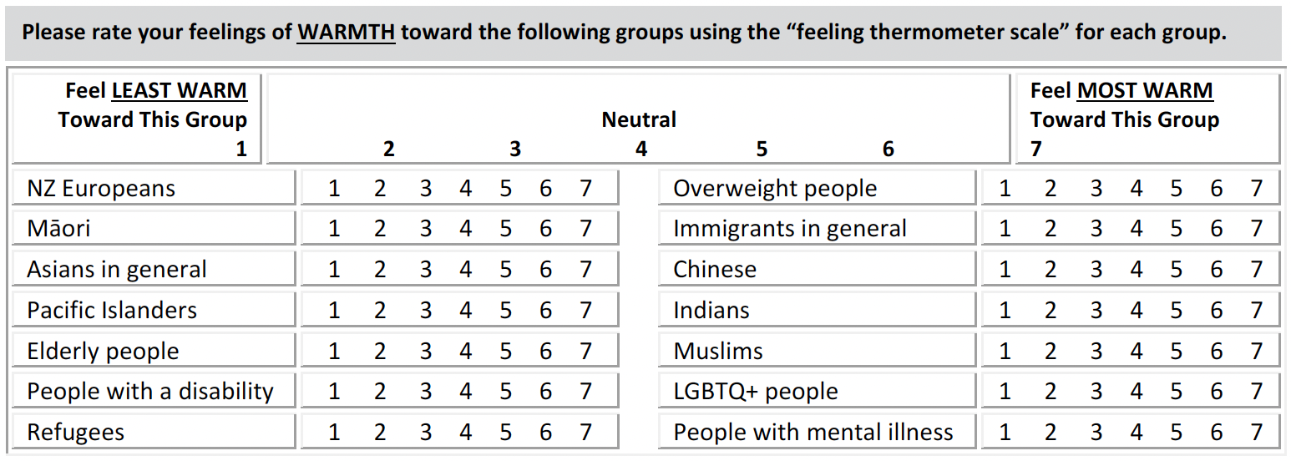

*Note*. From NZAVS Wave 15 <https://osf.io/75snb/>

Figure 2

Chronic disease diagnosis

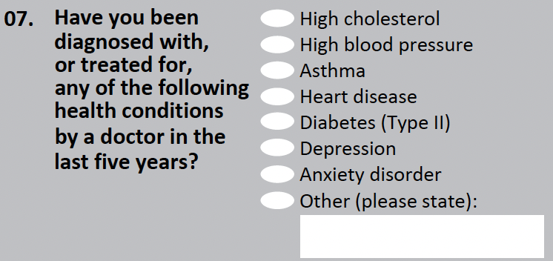

*Note*. From NZAVS Wave 15 <https://osf.io/75snb/>

Figure 3

Kessler-6 subjective wellbeing scale

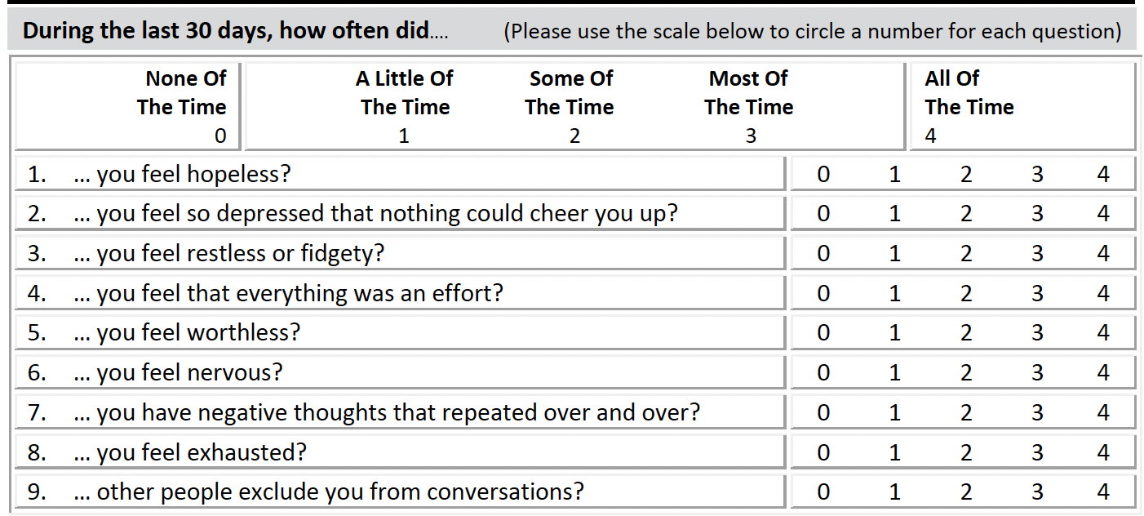

*Note*. From NZAVS Wave 15 <https://osf.io/75snb/>

Figure 4

Life Satisfaction scale

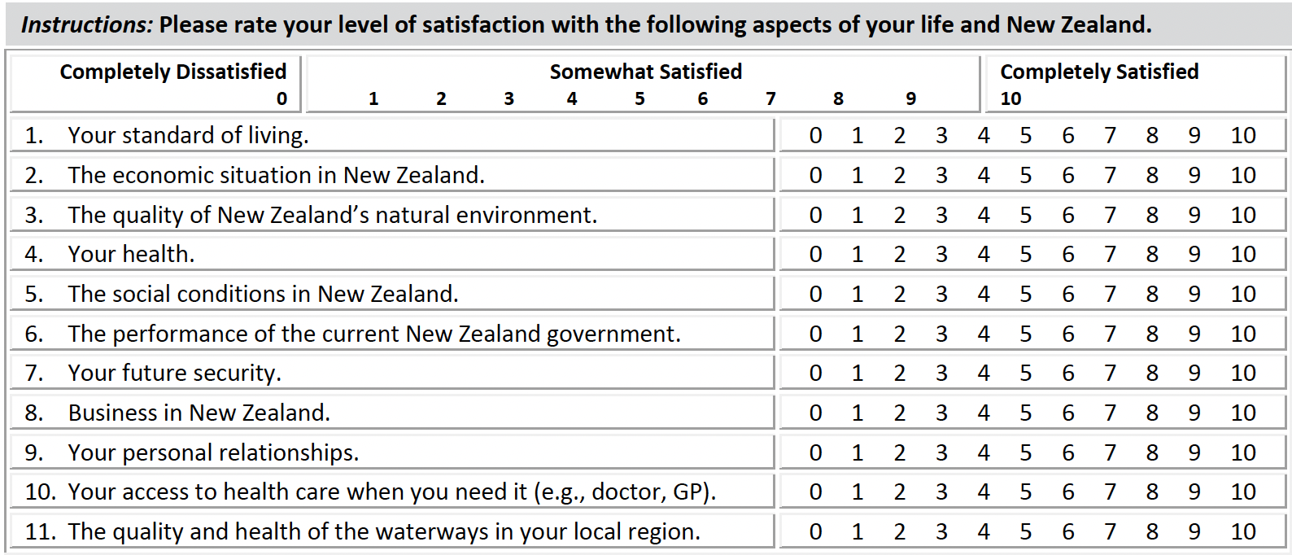

*Note*. From NZAVS Wave 15 <https://osf.io/75snb/>

Figure 5

Ethnic groups

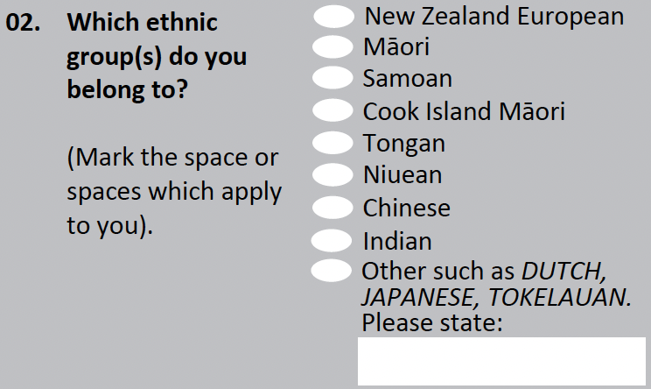

*Note*. From NZAVS Wave 15 <https://osf.io/75snb/>

Figure 6

MDS timeline showing tasks and durations

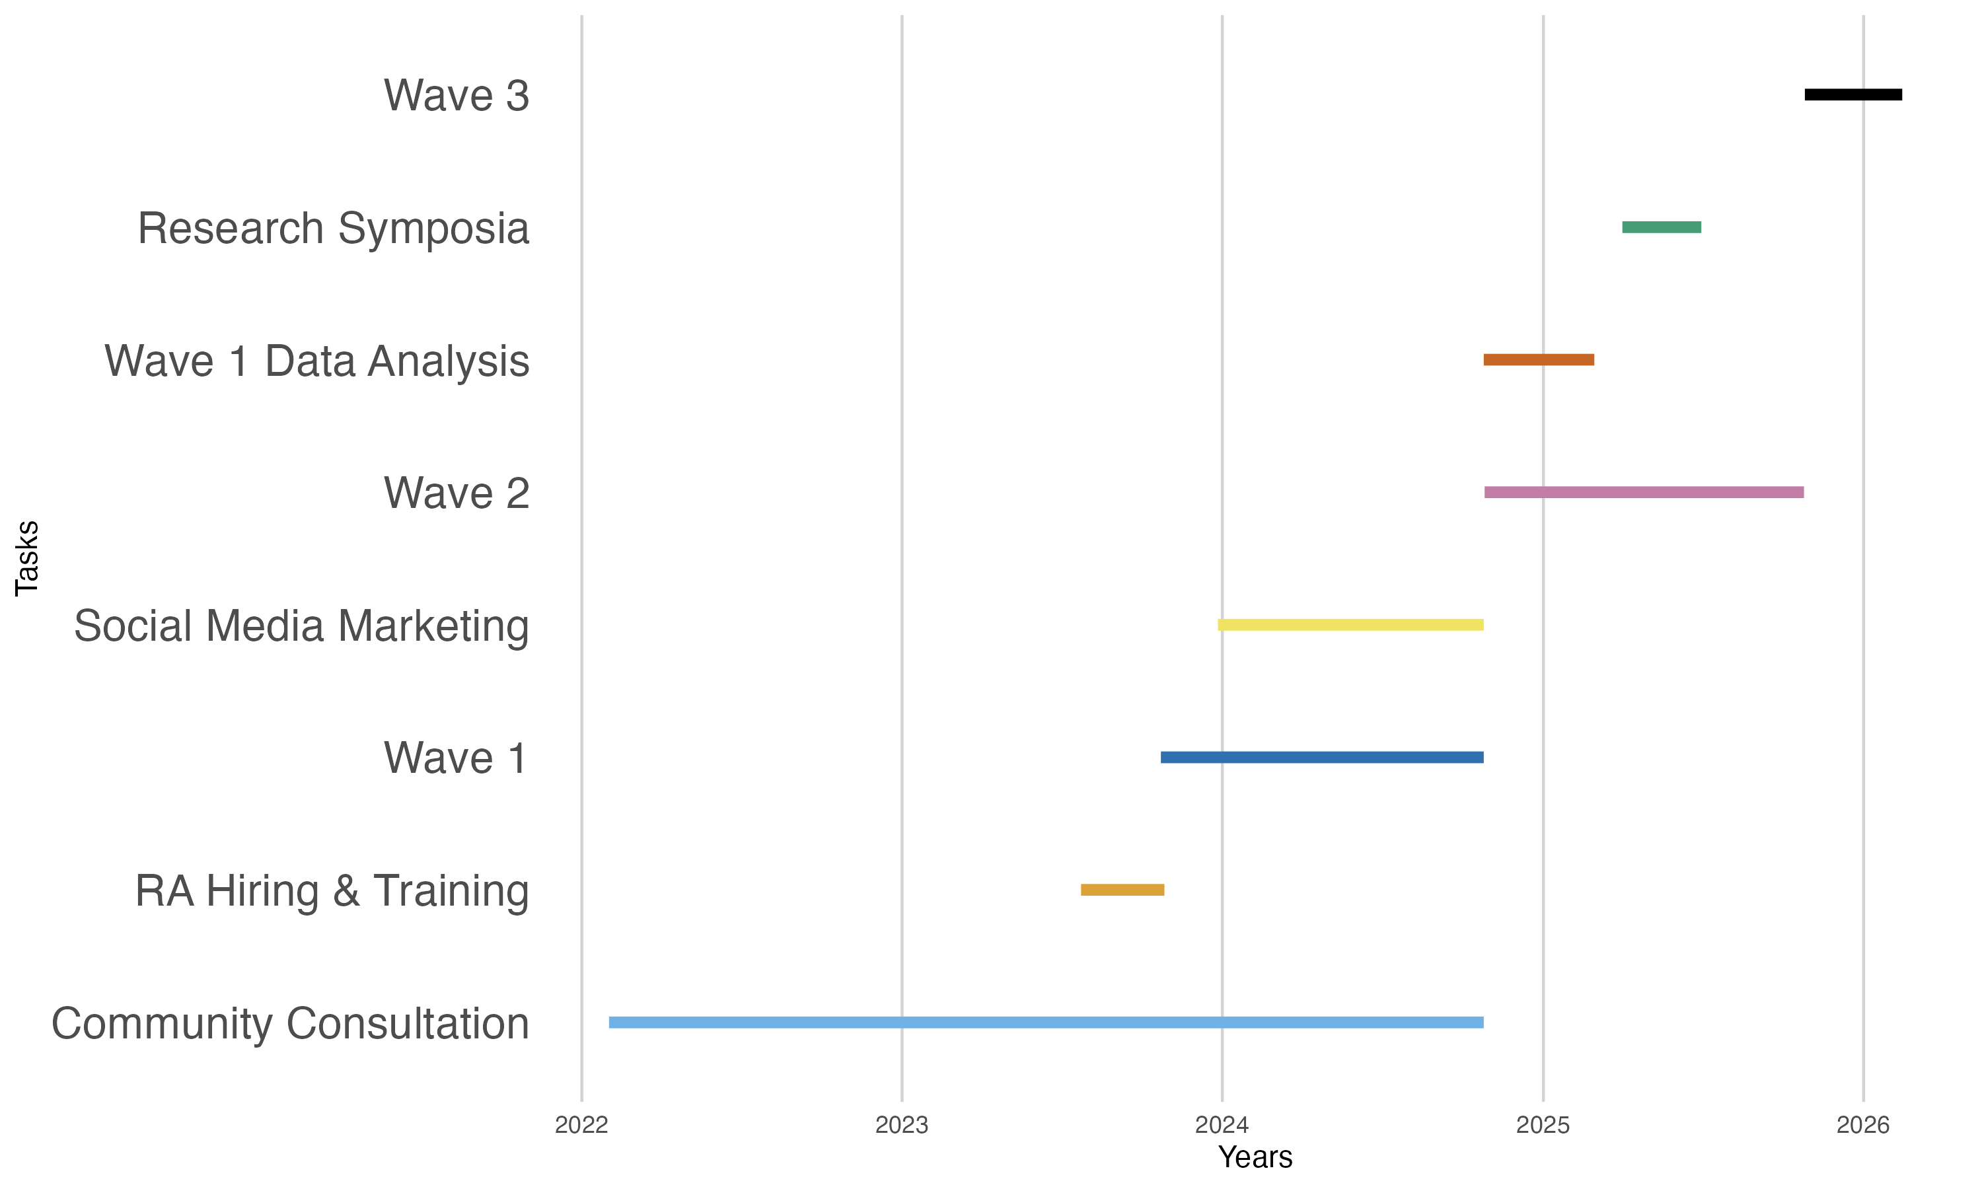

# Appendix

# MDS Runhseet

[Monospaced font refers to urls in the actual document.]

Salam alaikum and welcome to the Muslim Diversity Study.

1. This Dropbox folder consists of all information that you might need.
2. We have updated our communication and approach strategy, found here.
3. This document contains message to the community and FAQs. [will keep updating]
4. Cover letter for the Muslim Diversity Study.
5. MDS Questionnaire (pdf)
6. Use this message to send the MDS participation request to individuals. Please remember that individual connection is extremely important, and this is what we bank on.
7. Use this message to advertise MDS on social media (e.g., Facebook or LinkedIn); and to send it via WhatsApp or emailing lists to the wider community and organizations.
8. Use this message for shorter social media platforms (e.g., Twitter/X).
9. Access the poster (pdf) here (and png).
10. Access the flyer (pdf) here (and png).
11. This document can be shared with organizations to introduce MDS.
12. Organisation lists: Auckland, Hamilton, Palmerston North, Wellington, Christchurch, Dunedin. In addition, this is the list of organisations that have endorsed us or shared our ads. Please keep adding names to this list.
13. Please use this guideline for reaching out to organizations.
14. This story by UC has recorded the motivation behind MDS and its benefits for the Muslim community. It can be shared widely with those that want to know more.
15. The recent public lecture narrates the whole story of MDS (past, present, future) in a detailed manner. This, again, can be shared extensively with anyone interested.
16. Find our social media and website here.
17. The paper questionnaires are valuable, and to ensure meaningful responses, we shall only provide them to individuals who express interest and want them. Please distribute as many copies of flyers, and I can provide more flyers as needed.
18. Participants using the Qualtrics link should be reminded that they can resume the questionnaire from where they left off if they don’t complete it initially. Ideally, an additional message can be sent using this wording: “You can easily resume the questionnaire where you left off by clicking on the provided link. Feel free to complete the questionnaire in multiple sessions; your previous responses are automatically saved.” Since it’s not part of the ethics approval, it can be sent in the next message as additional guideline (instruction).
19. To claim your hours, log-in here.
20. If you are claiming your hours for the first time, use information in this folder.
21. If you want to have an update on collected data so far, see this.
22. I am thinking of a qualitative research project based on our experiences with the Muslim community where we’d want to interview our current RA’s. It’s briefly detailed here. If any of you are keen to be part of this or know someone who might want to take this on, please let me know. It can easily be a master’s thesis, and as detailed in the brief, it will attract great impact.
23. <https://linktr.ee/muslims_nz>
24. <https://linktr.ee/muslimdiversity>

# Appendix

# Message to Individual Participnats

Your Voice Matters! Join the Muslim Diversity Study!

Assalamu Alaikum WR WB [person’s name]

I’m [name of the RA], a research assistant in the Muslim Diversity Study.

We need YOUR perspective!

The Muslim community is underrepresented, and we’re changing that with your help. Participate in this first-of-its-kind survey to share your views on social attitudes, values, resilience, religiosity, flourishing, meaning-making, wellbeing, and experiences of Muslims in New Zealand. Let’s make our voices heard!

Why Participate?

Gather data on underrepresented Muslims, amplifying voices and providing insights into issues, wellbeing, and experiences.

Equip the Muslim community with evidence-based information for advocacy.

Enrich understanding, strengthening the collective voice, and shaping a more accurate narrative.

Your contribution counts and confidentially is assured!

By participating, you could potentially win one out of five $1000 grocery vouchers.

The data will be analysed with a focus on the Muslim community. Your input guides our research, ensuring authenticity and representation. We reassure you that the responses to the questionnaire are anonymized, encrypted, and aggregated in a manner that ensure confidentiality.

Spread the Word!

Please share with your friends, family, and community members! Let’s come together and make a difference.

To complete the questionnaire kindly click on the link below or message us for a paper copy: <https://www.nzavs.auckland.ac.nz/muslim_diversity>

For more info, visit our website (below) or reach out to Dr Usman Afzali (the lead researcher): (email address and contact phone number) <https://www.canterbury.ac.nz/science/schools/psyc-speech-hear/research/muslim-diversity/>

APPROVED BY THE UNIVERSITY OF AUCKLAND HUMAN PARTICIPANTS ETHICS COMMITTEE ON 26/05/2021 UNTIL 26/05/2027, REFERENCE NUMBER: UAHPEC22576.

# Appendix

# Community and Social Media Message

Your Voice Matters! Join the Muslim Diversity Study!

Assalamu Alaikum WR WB, Muslims in New Zealand!

We need YOUR perspective!

The Muslim community is underrepresented, and we’re changing that with your help. Participate in this first-of-its-kind survey to share your views on social attitudes, values, resilience, religiosity, flourishing, meaning-making, wellbeing, and experiences of Muslims in New Zealand. Let’s make our voices heard!

Why Participate?

Gather data on underrepresented Muslims, amplifying voices and providing insights into issues, wellbeing, and experiences.

Equip the Muslim community with evidence-based information for advocacy.

Enrich understanding, strengthening the collective voice, and shaping a more accurate narrative.

Your contribution counts and confidentially is assured!

By participating, you could potentially win one out of five $1000 grocery vouchers.

The data will be analysed with a focus on the Muslim community. Your input guides our research, ensuring authenticity and representation. We reassure you that the responses to the questionnaire are anonymized, encrypted, and aggregated in a manner that ensure confidentiality.

Spread the Word!

Please share with your friends, family, and community members! Let’s come together and make a difference.

To complete the questionnaire kindly click on the link below or message us for a paper copy: <https://www.nzavs.auckland.ac.nz/muslim_diversity>

For more info, visit our website (below) or reach out to Dr Usman Afzali (the lead researcher): (email address and contact phone number) <https://www.canterbury.ac.nz/science/schools/psyc-speech-hear/research/muslim-diversity/>

APPROVED BY THE UNIVERSITY OF AUCKLAND HUMAN PARTICIPANTS ETHICS COMMITTEE ON 26/05/2021 UNTIL 26/05/2027, REFERENCE NUMBER: UAHPEC22576.

# Appendix

Figure D1

MDS Flyer

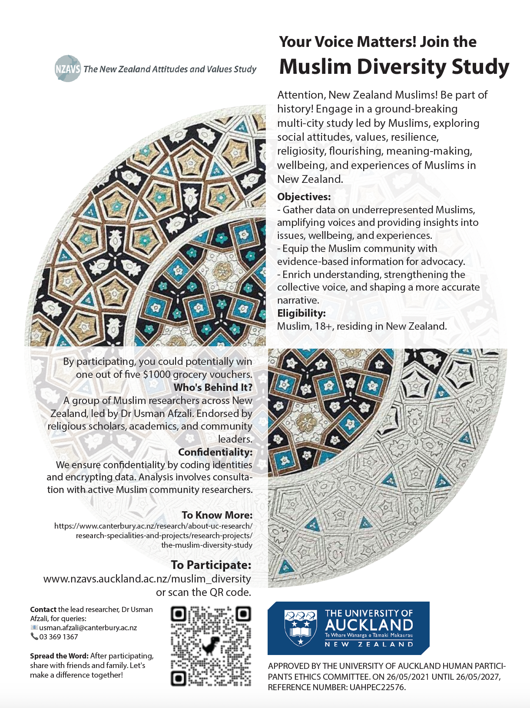

# Appendix

Figure E1

MDS Poster

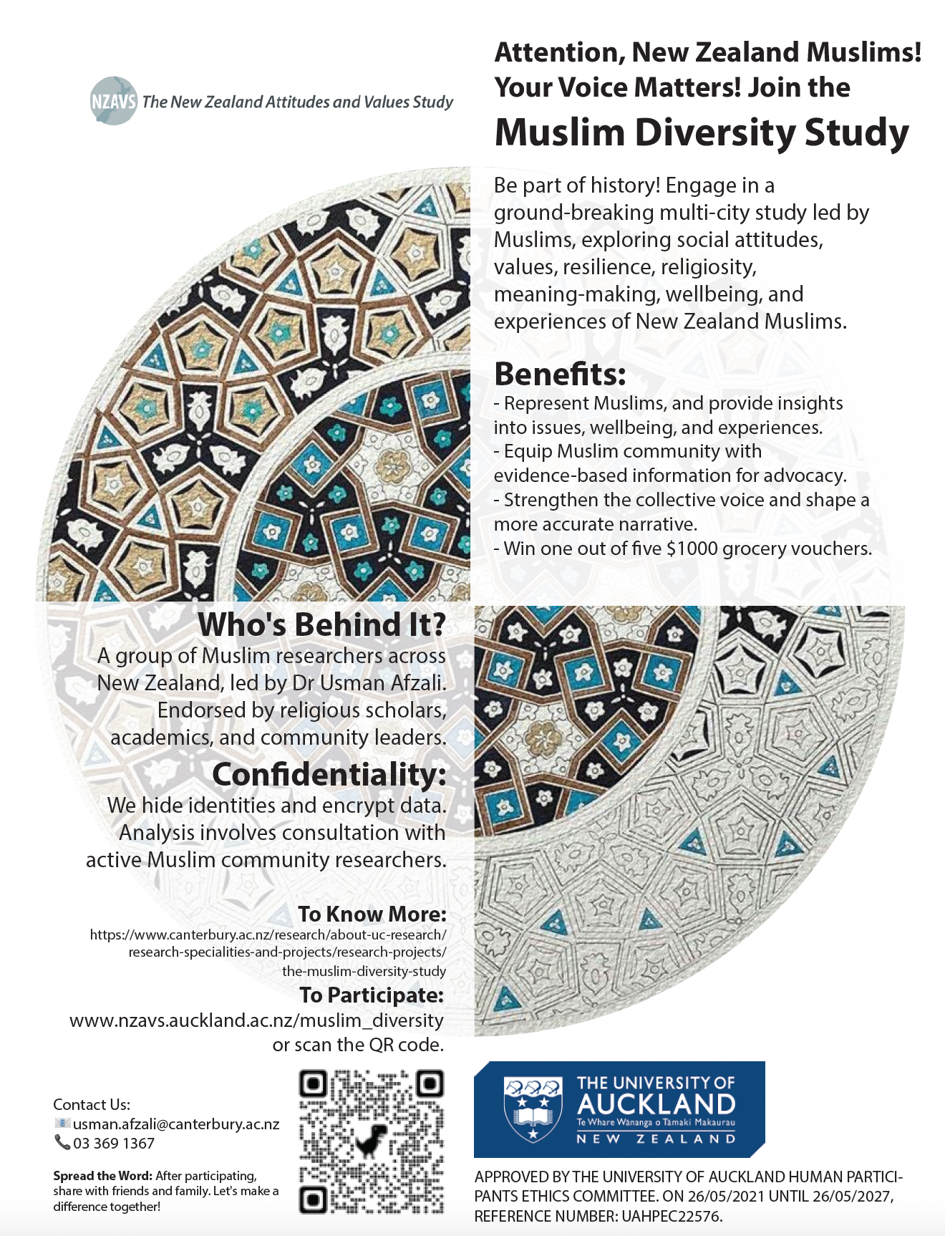

# Appendix

# MDS Vision

The NZAVS is committed to the following three principles for the Muslim Diversity Study.

Protection: The NZAVS is strongly committed to respecting and protecting data gathered from all participants and takes confidentiality seriously. Our commitment to participant privacy and safety is central to the NZAVS.

Participation: The NZAVS is committed to enhancing the research capacity of our communities in Aotearoa New Zealand. Any NZAVS research focusing specifically on the Muslim community will be reviewed by our Muslim academic advisor Dr Usman Afzali, and/or appropriate nominated reviewers from the Muslim community in New Zealand. We are committed to Muslim community-led research for Muslim-focussed studies to ensure respectful reporting that considers the social, religious, and cultural settings of New Zealand’s Muslims.

Partnership: The NZAVS actively fosters opportunities for collaborative research with emerging Muslim researchers in New Zealand. We seek to mentor Muslim graduate students interested in accessing NZAVS data for research in their own postgraduate theses or dissertations. We invite students from the Muslim community in New Zealand to contact our Muslim academic advisor, or any member of the NZAVS board or leadership team for guidance in developing a project.

# Appendix

## Participant confidentiality

Here at the NZAVS we take our participants’ confidentiality very seriously. All personal details are encrypted and stored separately from questionnaire data. Only Professor Chris Sibley and trusted research assistants working on the NZAVS in secure conditions have access to participants’ contact details. Participants’ contact details are used solely for the purposes of contacting them to continue their participation in the NZAVS each year and to provide them with information and feedback about research findings from the NZAVS.

Reference: <https://osf.io/75snb/wiki/home/>

## Ethics approval

The Muslim Diversity Study is regulated by the University of Auckland Human Participants Ethics Committee.

The current ethics approval statement for the 2021-2027 period is as follows: The New Zealand Attitudes and Values Study was approved by the University of Auckland Human Participants Ethics Committee on 26/05/2021 until 26/05/2024, and renewed on 02/05/2023 until 26/05/2027. Reference Number: UAHPEC22576.

For any queries regarding ethical concerns, you may contact the Chair, University of Auckland Human Participants Ethics Committee, Ethics and Integrity Team, University of Auckland, Private Bag 92019, Auckland 1142. Telephone 09 373-7599 ext. 83711. Email: [humanethics@auckland.ac.nz](mailto:humanethics@auckland.ac.nz).

## Why we need ethics approval?

Ethical approval for research is essential to ensure that studies involving human participants are conducted in a morally responsible and respectful manner. It serves to protect the rights, wellbeing, dignity, and confidentiality of those involved in the research, as well as the broader community affected by the study. Ethical approval ensures that potential risks are minimized, benefits are maximized, informed consent is obtained, and any potential conflicts of interest or biases are addressed. This oversight helps maintain public trust in the scientific community and upholds the fundamental principles of fairness, respect, and accountability in research endeavours.

# Appendix

# MDS Cover Letter

Salaam alaikum, kia ora, and greetings!

My name is Dr Usman Afzali, and I am the lead researcher of the Muslim Diversity Study. The Muslim Diversity Study is conducted as part of the New Zealand Attitudes and Values Study. This is a broad longitudinal study aiming to survey people from all across New Zealand (see the information sheet on the next page for more details).

As a researcher and committed member of the New Zealand Muslim community, I recognise the importance of including our voices in discussions about New Zealand. This inspired me to develop a booster study to enhance Muslim representation in the New Zealand Attitudes and Values Study, since we are underrepresented at present. I would be deeply grateful if you would consider participating in this survey. By sharing your perspectives, you will enrich our understanding of the attitudes, values, and wellbeing of the Muslim community in New Zealand. This will strengthen the voice of our community within New Zealand. We will publish the findings of our work in scientific journals, create brief reports and infographics, and present our findings to Muslim communities across New Zealand over the coming years.

My research team includes Muslim researchers from across New Zealand. By completing this survey, you are contributing to a research project led by people from the Muslim community for the Muslim community in New Zealand. Furthermore, analysis of the collected data, with a specific focus on the Muslim community, will not proceed without seeking consultation with researchers who are themselves part of the Muslim community.

As the survey is designed for the general New Zealand population, there may be questions that do not necessarily apply to you. Please feel free to skip any questions that you do not wish to answer. This study is funded by a research grant from a not-for-profit organisation, the Templeton Religion Trust, to help increase the participation of Muslims in the New Zealand Attitudes and Values Study.

|  |
| --- |
| If you would like to complete this questionnaire online instead of returning by post, please use: <https://www.nzavs.auckland.ac.nz/muslim_diversity>. |

If you have any questions or concerns regarding the Muslim Diversity Study, please do not hesitate to reach out to me, Dr Usman Afzali (contact details below). For general inquiries about the New Zealand Attitudes and Values Study, please contact Professor Chris Sibley (contact details below).

If you need help with understanding items of this questionnaire, feel free to reach out. Our researcher assistants are trained and have a detailed understanding of the questionnaire. Details are available at: <https://www.canterbury.ac.nz/science/schools/psyc-speech-hear/research/muslim-diversity/>

Your participation in this survey is highly valuable, and your input will significantly contribute to our understanding of the social values and attitudes of the Muslim community in New Zealand.

Sincerely,

Dr Usman Afzali,

School of Psychology, Speech and Hearing,

University of Canterbury, Private Bag 4800, Christchurch 8140.

(email address and phone number)

Professor Chris Sibley,

School of Psychology,

University of Auckland,

Private Bag 92019, Auckland 1142.

(email address)

APPROVED BY THE UNIVERSITY OF AUCKLAND HUMAN PARTICIPANTS ETHICS COMMITTEE ON 26/05/2021 UNTIL 26/05/2027, REFERENCE NUMBER: UAHPEC22576.